Week 1 Internship Documentation
Infosys Springboard Internship | Data Visualization Domain
Project Title: Optimizing IT Support Team Performance Using Analytics
Prepared by: Hindu Priya Boddu
Program: B.Tech (Data Science)


1. Introduction
The first week of the internship was focused on developing a strong conceptual foundation in data analysis, data visualization, data quality, and Power BI. The objective was not only to learn the tool interface, but also to understand why analytics projects succeed or fail based on the quality of the underlying data. In a real business environment, a dashboard is only as reliable as the data that powers it. Therefore, Week 1 concentrated on the essential theory and platform familiarization required before beginning actual project implementation.
This document captures the detailed learning outcomes, practical understanding, industry relevance, and beginner-level best practices acquired during the first week of the internship. It is written in a professional format suitable for mentor review, internship documentation, and future portfolio use.

2. What is Data Analysis?
Data analysis is the systematic process of collecting, organizing, cleaning, transforming, and interpreting data in order to discover useful patterns, trends, relationships, and actionable insights. The main purpose of data analysis is to convert raw data into meaningful information that supports better decision-making. In modern organizations, data analysis is used to understand business performance, customer behavior, operational bottlenecks, financial trends, and service quality.
In the context of an IT support or helpdesk environment, data analysis can answer questions such as: How many tickets are raised every day? Which ticket categories take the most time to resolve? Which support channels are most commonly used? Are response times improving or declining? Which priority levels create the highest workload pressure? These answers help management improve efficiency, reduce delays, and increase customer satisfaction.
- Transforms raw data into meaningful business insights
- Supports evidence-based decision making
- Helps identify inefficiencies, trends, anomalies, and performance gaps
- Forms the foundation of dashboards, reports, KPIs, and predictive models

3. What is Data Visualization?
Data visualization is the graphical representation of data using charts, graphs, maps, KPI cards, tables, and dashboards. It helps users understand large volumes of information quickly by presenting patterns visually instead of as raw numbers. Visualization is especially important because human beings understand shapes, comparisons, and trends faster than long rows of data in spreadsheets.
For example, if an IT support team has 10,000 tickets, a simple bar chart can immediately show which ticket categories are most frequent, while a line chart can show whether ticket volume is increasing over time. A KPI card can display the average first response time, and a pie or donut chart can summarize ticket priority distribution. Thus, visualization turns complex data into clear business stories.
- Makes complex data easy to understand
- Reveals patterns, trends, and outliers visually
- Improves communication with non-technical stakeholders
- Helps create dashboards for real-time monitoring

4. Why Data Analysis and Data Visualization are Necessary
Data analysis and visualization are necessary because modern organizations generate large amounts of data every day. Without analysis, this data remains unused and provides no business value. With proper analysis and visualization, organizations can monitor performance, detect issues early, allocate resources efficiently, and improve customer experience. In service-based environments such as IT support, analytics can directly impact service quality and operational efficiency.
- To identify bottlenecks in business processes
- To measure KPIs such as response time, resolution time, and satisfaction
- To support management with evidence instead of assumptions
- To reduce manual reporting effort through automated dashboards
- To improve operational efficiency and service quality

5. Process Overview of Data Analysis
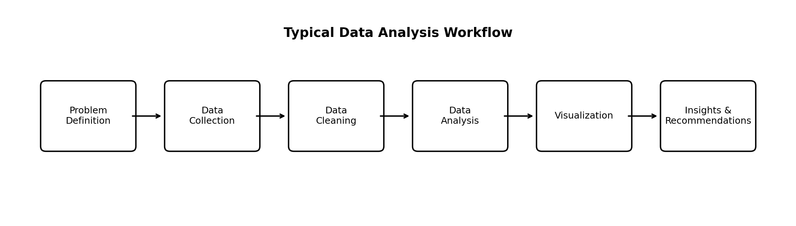
Figure 1: Illustrative workflow of a typical data analysis project
A standard data analysis workflow follows a sequence of well-defined steps. Although the exact process may vary depending on the project, the following framework is commonly used in industry:
- Problem Definition – Clearly understand the business problem, expected output, and project goals.
- Data Collection – Gather data from sources such as Excel files, databases, APIs, forms, or support systems.
- Data Cleaning – Fix missing values, duplicates, inconsistent formatting, incorrect data types, and invalid categories.
- Data Transformation – Prepare the data structure by splitting, merging, aggregating, or creating new columns.
- Exploratory Analysis – Identify trends, outliers, relationships, and quality issues in the data.
- Visualization & KPI Design – Build charts, tables, and KPI cards that answer business questions.
- Insight Generation – Interpret the visual outputs and identify important findings.
- Recommendation & Reporting – Suggest improvements and communicate findings to stakeholders.

6. Common Tools Used in Data Analysis
Data analysts use different tools depending on the type of project, data source, business requirement, and technical depth. During the first week of the internship, the focus was primarily on Power BI and foundational analytics concepts, but it is important to understand the broader tool ecosystem as well.
Tool | Purpose | Typical Use Case
Microsoft Excel | Basic data handling and review | Initial inspection, formulas, quick summaries
Power BI | Visualization and dashboarding | Interactive dashboards, KPI tracking, business reporting
Power Query | Data cleaning and transformation | Data shaping before analysis in Power BI/Excel
SQL | Database querying | Extracting and filtering data from relational databases
Python | Advanced analysis and automation | EDA, machine learning, scripting, data transformation
Git & GitHub | Version control and collaboration | Track changes, maintain project repository

For this internship project, the primary tool introduced in Week 1 was Power BI, which is widely used in the industry for business intelligence and interactive reporting.

7. Different Methods of Data Analysis
Data analysis can be performed in different ways depending on the business question. Understanding these methods is useful because they determine how a project is framed and what kind of dashboard or report is built.
Analysis Type | Meaning | Example in IT Support Context
Descriptive Analysis | Explains what happened | How many tickets were raised this month?
Diagnostic Analysis | Explains why it happened | Why did response time increase last week?
Predictive Analysis | Estimates what may happen | Which tickets are likely to breach SLA (Service Level Arrangement)?
Prescriptive Analysis | Suggests what action to take | How should tickets be reassigned to reduce delay?

In the initial stage of this project, the primary focus is on descriptive and diagnostic analysis, because the goal is to understand current performance and identify improvement areas before moving into advanced prediction.

8. What is Data Cleaning?
Data cleaning is the process of detecting and correcting inaccurate, incomplete, inconsistent, duplicated, or improperly formatted data before performing analysis. It is one of the most important and time-consuming stages of any analytics project. Raw data often contains errors such as missing values, repeated records, inconsistent labels, extra spaces, incorrect capitalization, invalid dates, and wrong data types.
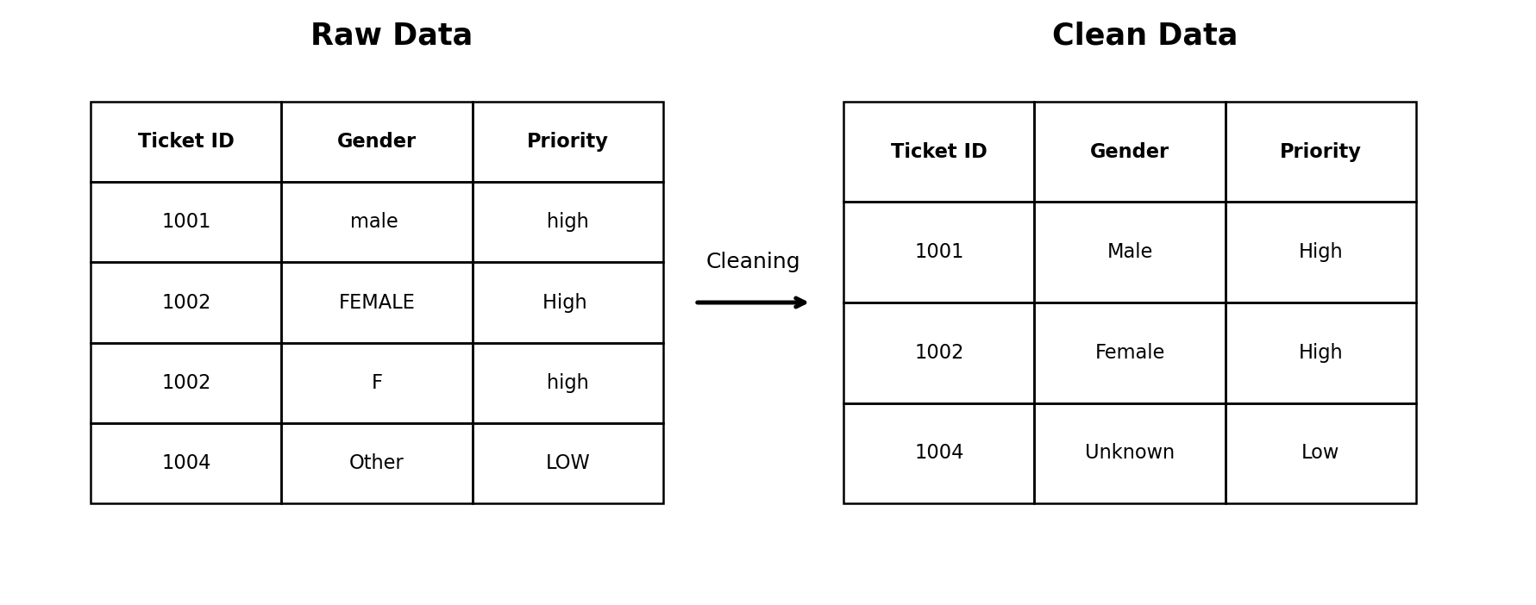
Figure 2: Example of raw data versus cleaned and standardized data
In practical projects, data cleaning ensures that the dataset becomes reliable enough to support KPI calculations, trend analysis, and dashboard reporting. Without cleaning, the final output may look visually attractive but can still be misleading or completely wrong.

9. Why Data Cleaning is Necessary
Data cleaning is necessary because business decisions depend on the correctness of the data. Even small inconsistencies can cause major issues in reports and dashboards. For example, if the same ticket priority appears as 'High', 'high', and 'HIGH ', Power BI may treat them as different categories, resulting in incorrect counts. Similarly, if a date column is stored as text instead of date format, time-based analysis will fail or produce incorrect trends.
- Prevents wrong KPI values
- Improves reliability of dashboards and reports
- Ensures consistency across categories and dimensions
- Reduces confusion during analysis and presentation
- Improves trust in business decisions based on data

10. How Data Cleaning Affects Accuracy
Data cleaning directly affects analytical accuracy. Accurate dashboards require accurate inputs. If the input data contains duplicates, total ticket count will be inflated. If the response time column contains text values or blanks, the average response time will be misleading. If ticket status values are inconsistent, the count of resolved or open tickets will be wrong. Therefore, data cleaning increases the accuracy, consistency, completeness, and reliability of the analysis.
Data Issue | Impact on Dashboard | Cleaning Benefit
Duplicate rows | Inflated counts | Correct totals and KPIs
Missing values | Biased averages | Reliable calculations
Wrong data types | Calculation errors | Proper aggregation and time analysis
Inconsistent labels | Split categories | Correct grouping and filtering
Extra spaces / case issues | False unique values | Standardized dimensions
In short, cleaning is not an optional step; it is a quality assurance process for analytics.

11. How Much Time Does Data Cleaning Require in Real Data Analyst Projects?
In real-world analytics projects, data cleaning often takes a significant portion of the total project time. A common industry observation is that 50% to 80% of the project effort may be spent on data collection, cleaning, validation, and transformation before actual dashboard creation begins. The exact time depends on data quality, number of sources, business complexity, and stakeholder requirements.
- Small clean dataset: 10%–25% of project time
- Moderately messy dataset: 30%–50% of project time
- Real-world business dataset: 50%–80% of project time
This is why Week 1 focused heavily on data quality concepts. Understanding cleaning early helps prevent major problems later in the dashboard development process.

12. What is Power BI?
Power BI is a Business Intelligence (BI) and data visualization tool developed by Microsoft. It allows users to connect to data from multiple sources, clean and transform it, build data models, create interactive reports and dashboards, and share insights with stakeholders. Power BI is widely used in industry because it combines data preparation, modeling, analysis, and visualization in a single ecosystem.
- Connects to Excel, CSV, SQL databases, web data, cloud sources, and more
- Includes Power Query for data cleaning and transformation
- Supports relationships and data modeling
- Allows creation of interactive dashboards and reports
- Provides DAX for calculated columns and measures

13. Why Power BI is Important in Industry
Power BI is popular because it is user-friendly for beginners, yet powerful enough for enterprise-level reporting. It supports interactive dashboards, drill-through analysis, filters, slicers, row-level security, scheduled refresh, and strong integration with Microsoft tools. For internship and placement purposes, Power BI is a valuable skill because many companies use it for reporting and performance monitoring.
- Easy to learn compared to many enterprise BI tools
- Strong integration with Excel and Microsoft ecosystem
- Interactive and visually rich dashboards
- Good balance of beginner accessibility and professional depth
- Highly relevant for analyst and business intelligence roles

14. Familiarization with Power BI Interface
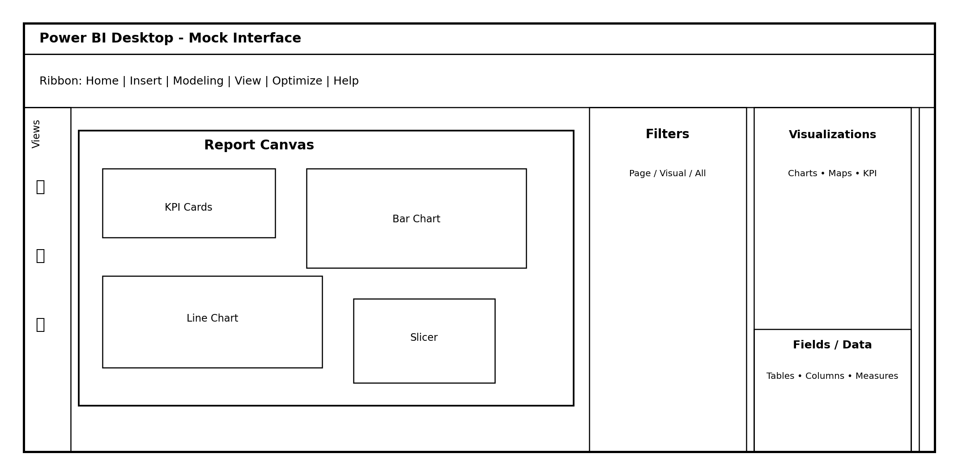
Figure 3: Illustrative mock layout of the Power BI Desktop interface
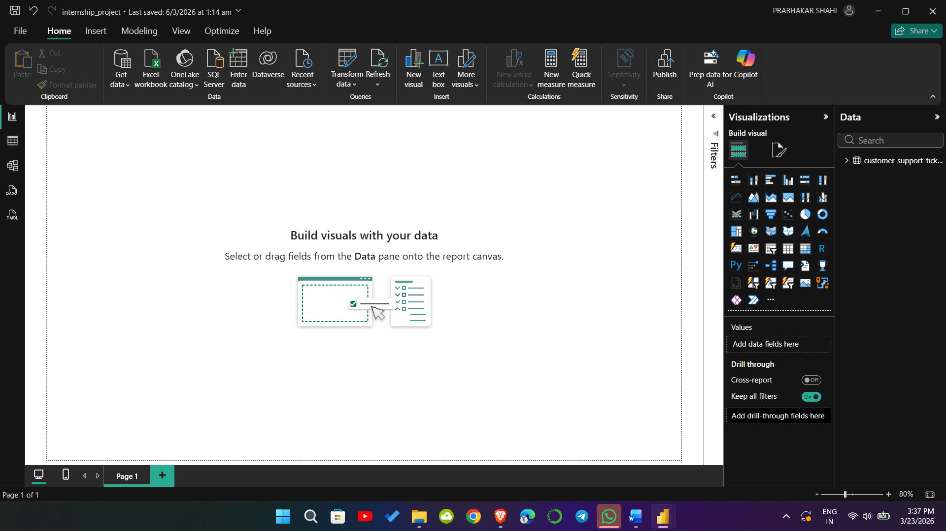
Figure 4: Illustrative layout of the Power BI Desktop interface
During Week 1, the main objective in Power BI was to become familiar with the interface and understand the role of each section. Before building reports, a data analyst must know where to import data, where to transform it, where to create visuals, and how to navigate between different views.

15. Major Components and Panels in Power BI Desktop
Component / Panel | Function
Ribbon | Contains main commands such as Get Data, Transform Data, Refresh, New Visuals, Modeling, and View settings
Report View | Main canvas used to build charts, KPI cards, slicers, and dashboards
Data View | Used to inspect tables and columns in tabular form after loading data
Model View | Used to create and inspect relationships between tables
Filters Pane | Applies filters at visual level, page level, or report level
Visualizations Pane | Contains chart types and formatting options for selected visuals
Fields / Data Pane | Displays tables, columns, and measures available for reporting
Canvas | Central area where visuals are arranged and dashboard layout is created

16. Ribbon Tabs and Their Functions
The ribbon is the command bar at the top of Power BI Desktop. It is similar to Microsoft Office applications and provides access to the most important actions. Understanding the ribbon helps users move efficiently between importing data, cleaning data, modeling, and designing reports.
Ribbon Tab | Typical Use
Home | Get Data, Transform Data, Refresh, Enter Data, Publish, New Visuals
Insert | Text box, buttons, shapes, images, and other report elements
Modeling | New Measure, New Column, Manage Relationships, Formatting
View | Themes, page view, pane visibility, gridlines, sync slicers
Optimize / Performance | Performance analyzer and optimization-related options
Help | Learning resources, updates, community links, and support

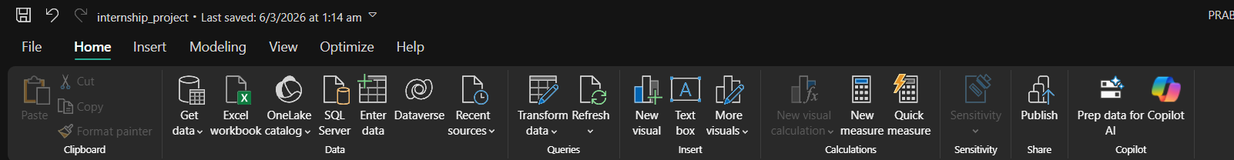
Figure 5: Illustrative Ribbon Tabs of the Power BI Desktop interface

17. Report View, Data View, and Model View
Power BI provides three major working views, and understanding their purpose is essential for a beginner.
- Report View – Used to create the final dashboard or report page. This is where charts, cards, slicers, and text boxes are placed.
- Data View – Used to inspect the loaded data table, verify columns, and quickly check whether data looks correct after import.
- Model View – Used to create and manage relationships between tables. This is especially important when multiple tables are used in the same report.

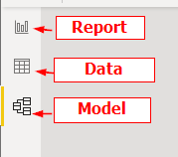
Figure 6: Illustrative Report , Data and Model View of the Power BI Desktop interface

18. Important Related Concepts Added for Completeness
To make the Week 1 documentation complete and industry-relevant, the following related topics are also important even if they were not explicitly listed in the initial outline.
- Raw Data vs Clean Data – Raw data is unprocessed and may contain errors; clean data is standardized and ready for analysis.
- Structured vs Unstructured Data – Structured data fits rows and columns; unstructured data includes emails, text, and documents.
- Dashboard vs Report – A dashboard is a summarized visual overview; a report can be more detailed and multi-page.
- KPI (Key Performance Indicator) – A measurable metric used to evaluate performance, such as average response time or ticket resolution rate.
- Data Quality Dimensions – Accuracy, completeness, consistency, validity, uniqueness, and timeliness.
- ETL Basics – Extract, Transform, Load; a common process used in analytics and BI workflows.
- Stakeholder Communication – The best dashboard is one that answers business questions clearly for the intended audience.

19. Beginner Best Practices in Power BI
- Always inspect the data before building visuals
- Check data types immediately after loading data
- Standardize category values
- Avoid building charts before cleaning the dataset
- Use meaningful column names and table names
- Keep report layout clean and avoid visual clutter
- Focus on business questions before choosing chart types
- Document every cleaning step for transparency and reproducibility

20. Week 1 Learning Summary
The first week of the internship established the conceptual and technical foundation necessary for the successful execution of the project. The learning covered the meaning and importance of data analysis, the role of data visualization in communicating insights, the standard workflow of analytics projects, the significance of data cleaning, and the impact of data quality on accuracy. In addition, the week included practical familiarization with Power BI Desktop, including the ribbon, report view, data view, model view, filters pane, visualizations pane, and fields pane.
This foundation is highly relevant to the project titled 'Optimizing IT Support Team Performance Using Analytics' because the final dashboard will depend on clean, structured data and a proper understanding of how to convert business questions into measurable KPIs and interactive visuals.

21. Conclusion
Week 1 was focused on learning the fundamentals that are essential before beginning any serious analytics project. Instead of directly jumping into dashboard creation, the week emphasized understanding data, appreciating the importance of cleaning, and becoming comfortable with the Power BI interface. This is a professional and correct approach because it reduces errors, improves confidence, and creates a stronger base for future project work.
In the upcoming weeks, this foundation will support more advanced tasks such as Power Query transformations, dataset preparation, KPI creation, DAX measures, and dashboard design for IT support team performance optimization.

